**AMAN KUMAR SHARMA**

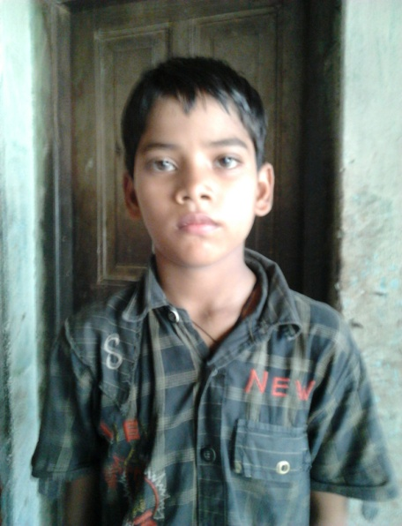

**PERSONAL DETAILS:**

* Class: IV
* Gender: Male
* School: Gayatri Shiksha Niketan,

Adityapur

* Board of School: CBSE
* Medium of instruction: English

**DETAILS ABOUT FAMILY:**

* Father’s name: Akhilesh Singh
* Mother’s name: Balika Devi
* No of members in family: Five- three brothers, mother and father
* Profession of father: Machine operator in a local company in Adityapur Industrial Area
* Profession of mother: Housewife

**FINANCIAL OVERVIEW:**

Monthly net income of household: Rs. 3500/-

**Total annual expenditure on education: Rs. 16,500/-**

Breakup of expenses

Tuition fees: Rs 550/- (per month) = Rs. 6600/- (per year)

Admission fees: Rs. 2100/- (per year)

Computer fees: Rs. 50/-(per month)= Rs. 600/- (per year)

Stationery: Rs. 3000/- (per year)

Bus fare: Rs. 350/-(per month) = Rs. 4200/- (per year)

**Average monthly expenditure on education: Rs. 1375/-**

**ENCLOSURES:**

1) Report card for the final exam of class III (previous class attended).

Report card – Page 1

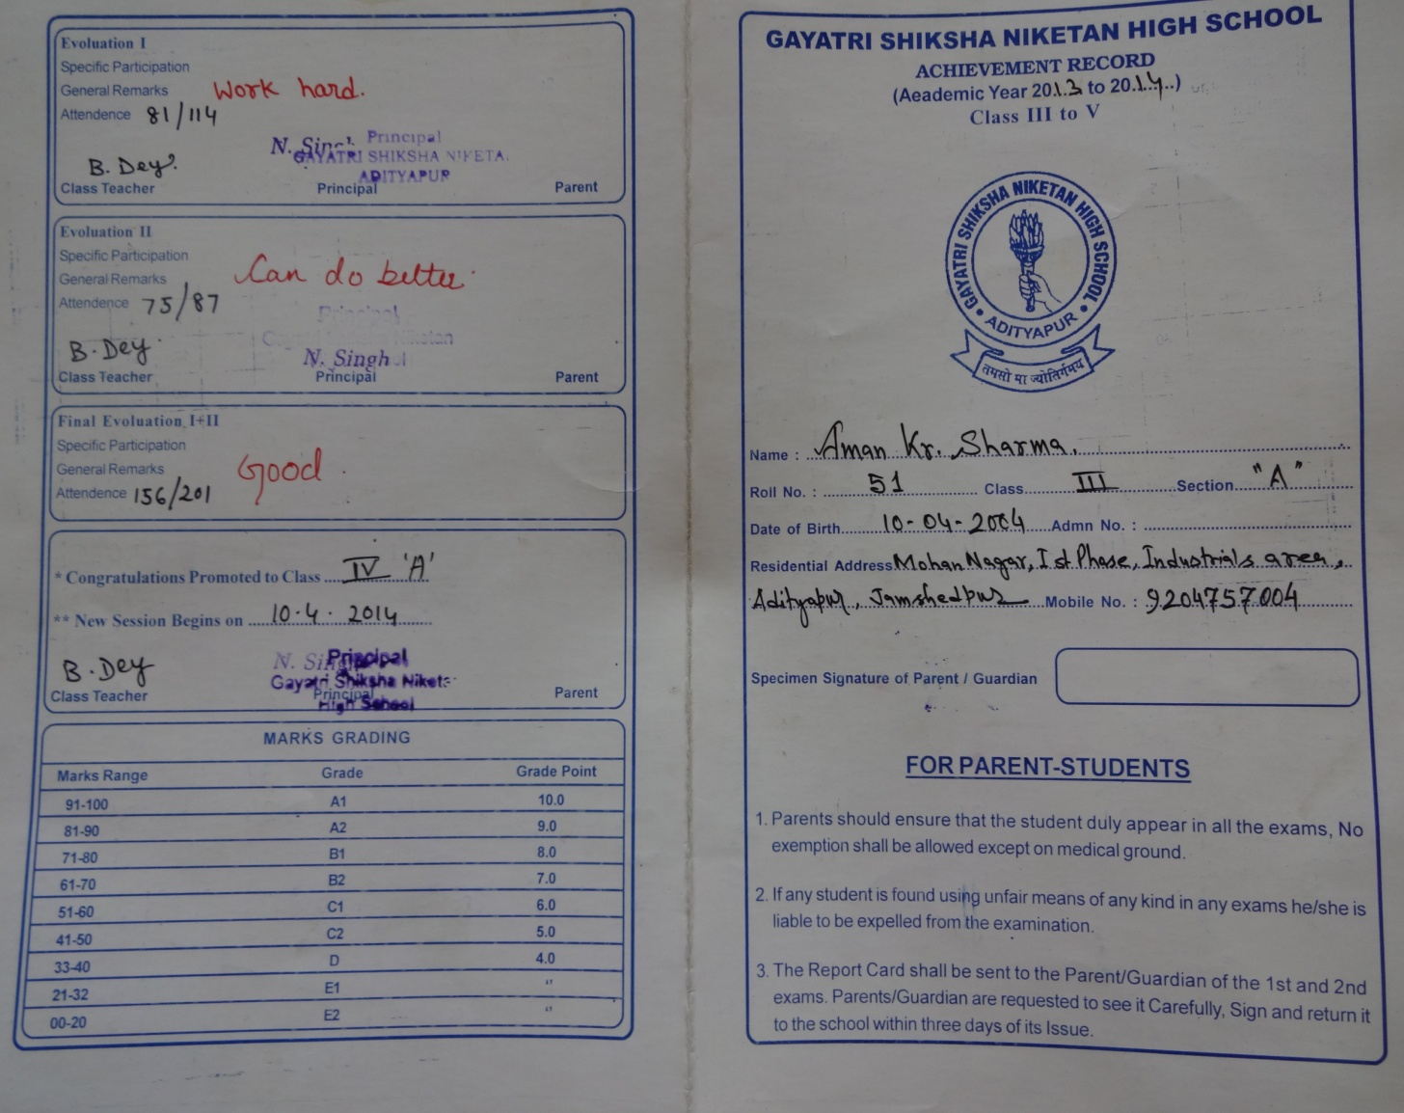

Report card – Page 2

